**WEB DEVELOPMENT INTERNSHIP PROJECT 1**

**Name**: Pratik Pawar

**Project Title:** Image Slider

**Internship Name:** Web Development Internship

**Submission Date:** 05/02/2025

**Email:** pratikpawar7225@gmail.com

**Phone number:** 9552524565

**Table of Contents**

1. Introduction
2. Objective
3. Project Details
4. Features Implemented
5. Challenges and Learnings
6. Responsive Design and Testing
7. Code Snippets
8. Screenshots
9. Conclusion

**Introduction**

In this project, we developed a dynamic image slider using HTML, CSS, and JavaScript. The image slider is designed to showcase multiple images with smooth transitions, providing an engaging and interactive user experience. This project was undertaken as part of the Web Development Internship Program (Week 2).

**Objective**

The objective of this project is to create an image slider that can display multiple images in a rotating fashion. The slider includes navigation controls to move between images and is fully responsive, ensuring smooth adaptation to different screen sizes.

**Project Details**

The image slider consists of:

* A container for the slider.
* A set of images that transition automatically.
* Navigation buttons (Next and Previous) for manual image switching.
* Auto-sliding functionality to change images at a set interval.
* Smooth animations for seamless transitions.

**Features Implemented**

* **HTML Structure:** Created a structured layout with placeholders for images and navigation controls.
* **CSS Styling:** Styled the slider, images, and navigation controls for a visually appealing interface.
* **JavaScript Functionality:** Implemented logic for auto-sliding, navigation controls, and responsive behavior.
* **Responsive Design:** Ensured the slider adapts to different screen sizes for optimal viewing.
* **Smooth Transitions:** Added animations to enhance the visual experience.

**Challenges and Learnings**

* **Handling Image Transitions:** Implementing smooth transitions without lag required fine-tuning of CSS animations.
* **Responsive Design:** Ensuring the slider works well across different screen sizes was a crucial learning experience.
* **Navigation Functionality:** Managing user interactions effectively with JavaScript enhanced our understanding of event handling.

**Screenshots.**

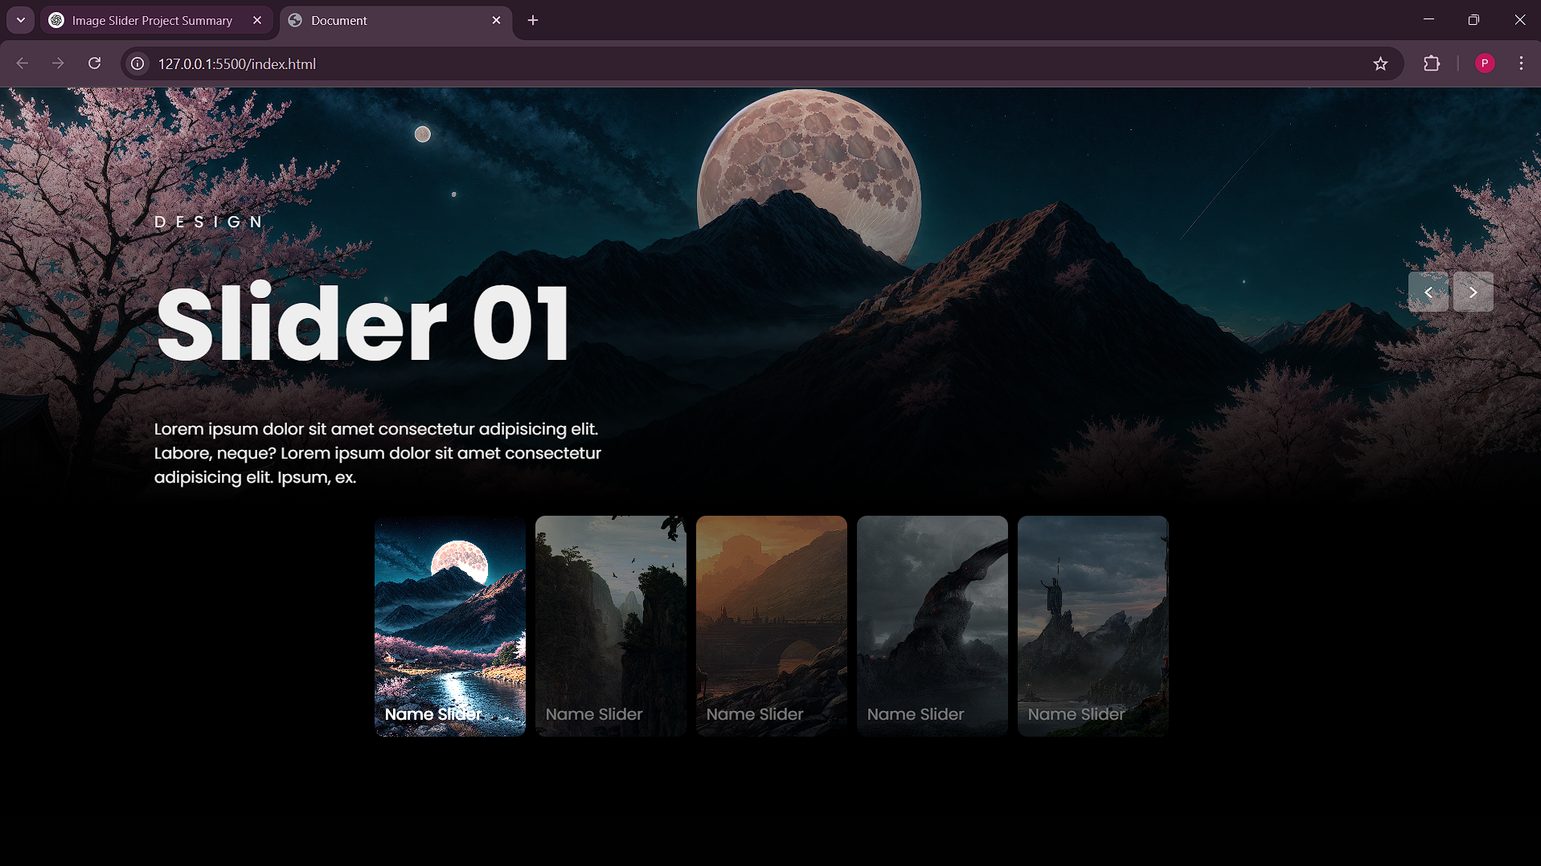

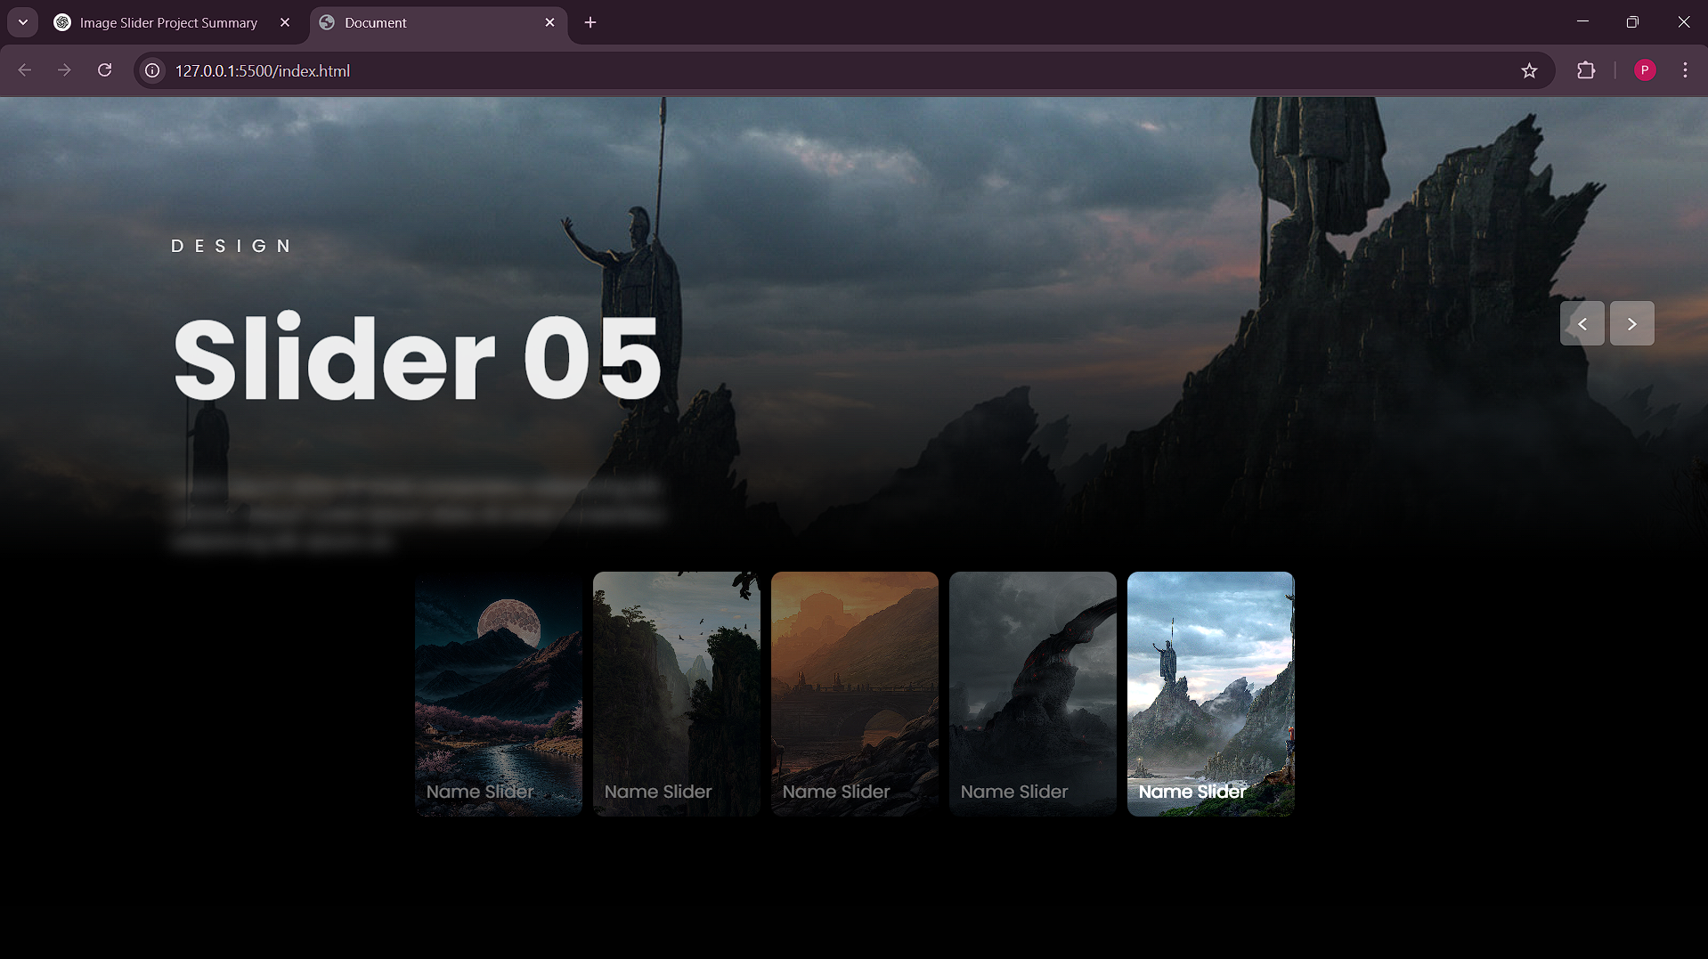

**Conclusion**

This project enhanced our understanding of front-end web development, particularly in working with dynamic content using HTML, CSS, and JavaScript. By implementing this image slider, we gained experience in animations, event handling, and responsive design principles. Future enhancements could include thumbnail navigation, captions, and additional transition effects.